* Rajasthani Folk
* Bhangada
* Lavani
* Kashmiri
* Manipuri
* Any Other
* Garaba
* Ras
* Hudo
* Tippani
* Manjira Nrityam
* Bharatnatyam
* Kuchipudi
* Kathak
* Orissi
* Other Classical Dances

**Check, if Student has learnt Dance Style in the past**

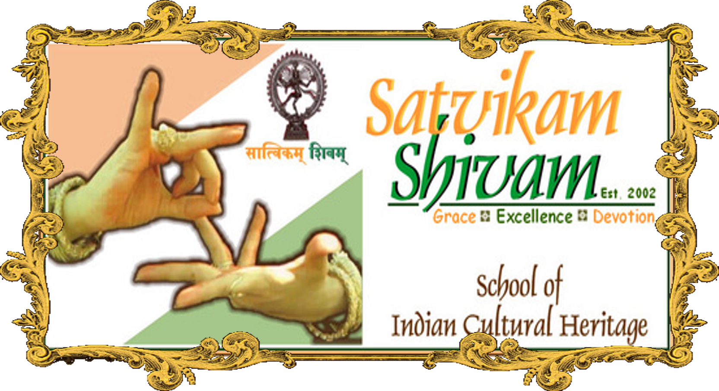

**The dream & mission of "Satvikam Shivam"**

**is to pass Indian cultural heritage and history to Indo-American generations**

**and others who are curious about learning Indian Dances**

**and other Traditional Arts and to be part of new visions in creative innovations**

**Student Information**

**\*Name** _______________________________________________________________________

**\*Birth Date ___________________ Education Details _______________________**

**Address _______________________________________________________________________**

Street City State & Zip

**\*Phone _______________ _______________ Email _________________________________**

**Other Hobbies _________________________________________________________________**

**Parents Information**

**\*Name ______________________________________________________________________**

**Contact Address ______________________________________________________________**

Street City State & Zip

**Other Phone ______________ ______________Email_________________________________**

**Other Contact Information ____________________________________________**

**Previous Dance Training/Performance Experience ______________________________**____________________________________________________________________________________________________________________________________

* Mandatory (All information will be kept in strict confidence)

Since 2002

* Bhangara
* Lavani
* Hudo
* Tippani

**Check, if Student is interested in learning -**

* Bharatnatyam
* Garaba
* Ras
* Rajasthani Folk
* Other __________________

**Joining date: / /20**